Vimeo

Account credentials:

https://vimeo.com/
Username - mukul.sharma@pinkvilla.com
Password - xiY_7roTr1W#ku6Odroy

https://developer.vimeo.com/apps/232963
App : pinkvillaApp
Token : 4836eeb7896adf5e58e3bbbaebcd38fd

Backend Functionality:

For Create new Videos

- Video Articles
http://172.20.4.37/wp-admin/admin.php?page=workspace_video_gallery_create

- Fill all mandatory fields like headline, Strap etc
- In Videos Details section, Video Type should be short video and Select Platform will be Vimeo and add Video id in Video Id fields

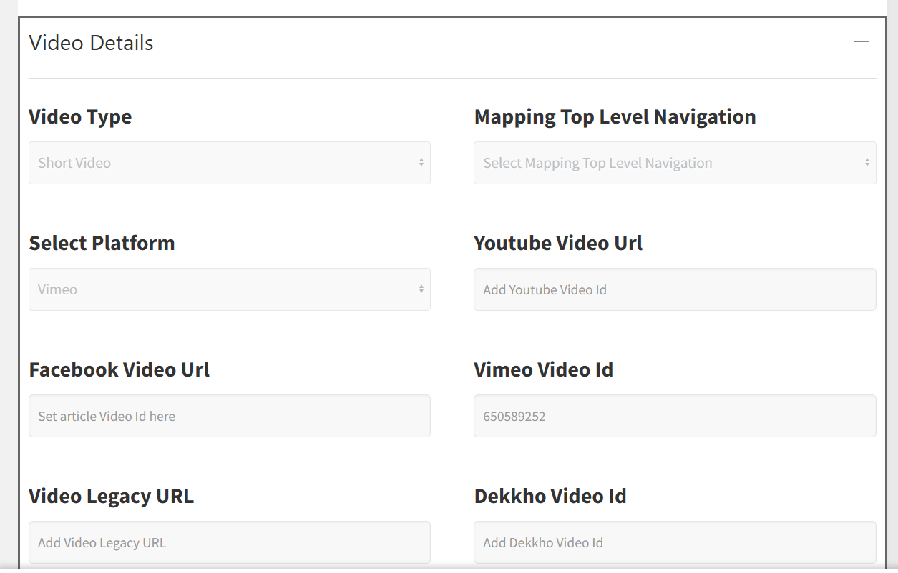

- Select author and published video article.

Backend Templates Structured :
File path :
wp-content\plugins\video\templates\workspace
For create video articles : create.php
For edit existing articles : edit.php
For view video articles: view.php

API Callbacks
File path:
wp-content/plugins/video/inc/Api/Callbacks/AdminVideoCallbacksWorkspace.php

store workspace normal in published mode when click on save and exit mode
function storeVideoWorkspace()

For get data in edit.php Template
function editVideoWorkspace()

For view data in view.php Tempalte
function viewVideoWorkspace()

For update published video articles
function updateVideoWorkspace()

Front-end Functionality :

Routes :
\routes\web.php
$router->get('/{section}/{subSection}/{slug}', 'ArticleControllerV2@article');
Controller
\app\Http\Controllers
ArticleControllerV2.php
public function videoArticle($article, $section, $subSection = "",$slug="")

Vimeo id convert logic
if ($article['lead_video_platform'] == 'vimeo') {
$vimeoID = isset($article['vimeo_video_url']) ? $article['vimeo_video_url'] : '';
if(!empty($vimeoID)){
$isVimeoVideoExist = $this->redisClient->getKey($this->siteName . 'vimeo_video_url_' . $vimeoID);
if (isset($isVimeoVideoExist) && $isVimeoVideoExist) {
$article['vimeo_video_url'] = $isVimeoVideoExist;
} else {
$article['vimeo_video_url'] = $this->storeVimeoVideoUrl1($vimeoID);
if(empty($article['vimeo_video_url'])){
$article['vimeo_video_url'] = $this->storeVimeoVideoUrl1(378507293);
}
}

} else{
$vimeoID = '378507293';
$isVimeoVideoExist = $this->redisClient->getKey($this->siteName . 'vimeo_video_url_' . $vimeoID);
if(empty($isVimeoVideoExist)){
$article['vimeo_video_url'] = $this->storeVimeoVideoUrl1($vimeoID);
}
$article['vimeo_video_url'] = $isVimeoVideoExist;
}
}

Template
Desktop :
\resources\views\desktop\pages\articlev2
video.blade.php
Mobile :
\resources\views\mobile\pages\articlev2
video.blade.php

